Examples of Businesses in Narrogin, WA

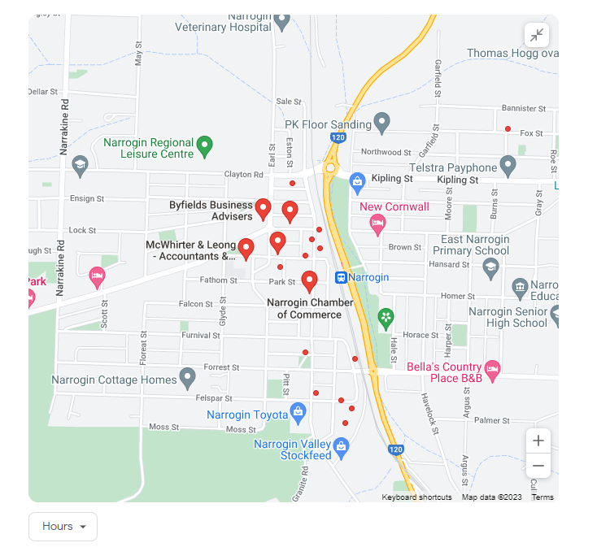
Map: 1 of businesses in Narrogin

Map:2 of businesses in Narrogin
